Project Report: Calculating Family Expenses Using ServiceNow
Date | 21 February 2026
Team ID | LTVIP2026TMIDS77557
Project Name | Calculating family expenses using ServiceNow
Team Members | Likhitha Jami  S N L M Sowmya Srivalli Allam  Mattaparthi Siva Satya Rahul  Bobbadi Gangadhar

1. INTRODUCTION
1.1 Project Overview
The Family Expense Tracker is a robust, cloud-based application developed on the ServiceNow platform. It is designed to modernise household financial management by transitioning away from manual, paper-based tracking to a digital, automated, and analytical approach. The application enables users to log daily expenditures, which are then categorised and summarised to provide a transparent view of family spending behaviour.
1.2 Purpose
The purpose of this project is to provide a scalable, secure, and user-friendly platform for tracking domestic finances. By leveraging ServiceNow's enterprise capabilities, the project aims to solve common issues such as calculation errors, loss of receipt data, and lack of historical spending insights, thereby empowering families to manage their budgets effectively.

2. IDEATION PHASE
2.1 Problem Statement
Families currently face significant challenges in tracking day-to-day expenses, leading to unplanned overspending and financial stress. The absence of a unified system means that financial data is often scattered across physical receipts, text messages, or disparate applications, making it impossible to perform meaningful data analysis.
2.2 Empathy Map Canvas
Category | User Perspective & Details
Says | - I need a simple way to track all our expenses.  - I don’t know where all my money goes each month.  - We should save more, but expenses keep increasing.  - Maintaining records manually is time-consuming.
Think | - I need a simple way to track all our expenses.  - I don’t know where all my money goes each month.  - We should save more, but expenses keep increasing.  - Maintaining records manually is time-consuming.
Do | - Writes expenses in notebooks or Excel sheets.  - Checks bank messages for transaction details.  - Discusses spending with family members.  - Tries to estimate monthly totals manually.
Feel | - Stressed about financial uncertainty.  - Frustrated with lack of proper tracking.  - Confused about spending patterns.  - Motivated to improve savings and budgeting.

2.3 Brainstorming
The team brainstormed solutions focusing on core ServiceNow platform features:
- Step 1: Team Gathering, Collaboration and Problem Statement Selection
- Step 2: Brainstorming, Idea Listing and Grouping
- Step 3: Idea Prioritization

3. REQUIREMENT ANALYSIS
3.1 Customer Journey Map
- Stage 1 (Onboarding): User logs in and selects the active "Family Expense" record for the current month.
- Stage 2 (Entry): User submits a "Daily Expense" record with details: Date, Item, Category, and Amount.
- Stage 3 (Processing): The system automatically links the entry to the parent record and updates the total.
- Stage 4 (Analysis): The user navigates to the dashboard to view graphical spend distributions.
3.2 Solution Requirement
- Scalability: Must support multiple family members and years of historical data.
- Automation: Zero manual calculation required for month-end summaries.
- Usability: Responsive design accessible via mobile devices for "on-the-spot" logging.

3.3 Data Flow Diagram
- User Input (Service Portal/Native UI) → 2. Scripted Business Rule → 3. Relational Table Update (Family Expense Table) → 4. Dashboard View (Data Visualisation).
3.4 Technology Stack
The architecture includes:
- User Interface (Web UI, Mobile App)
- Application Logic (Expense Management, Dashboard, Reports, Admin Management, Support)
- Database (MySQL/PostgreSQL)
- Cloud Deployment (AWS/ServiceNow)
- File Storage (Cloud Storage or Local Filesystem)
- External APIs (Email API, Payment API)
- Infrastructure (Cloud Server, Kubernetes)
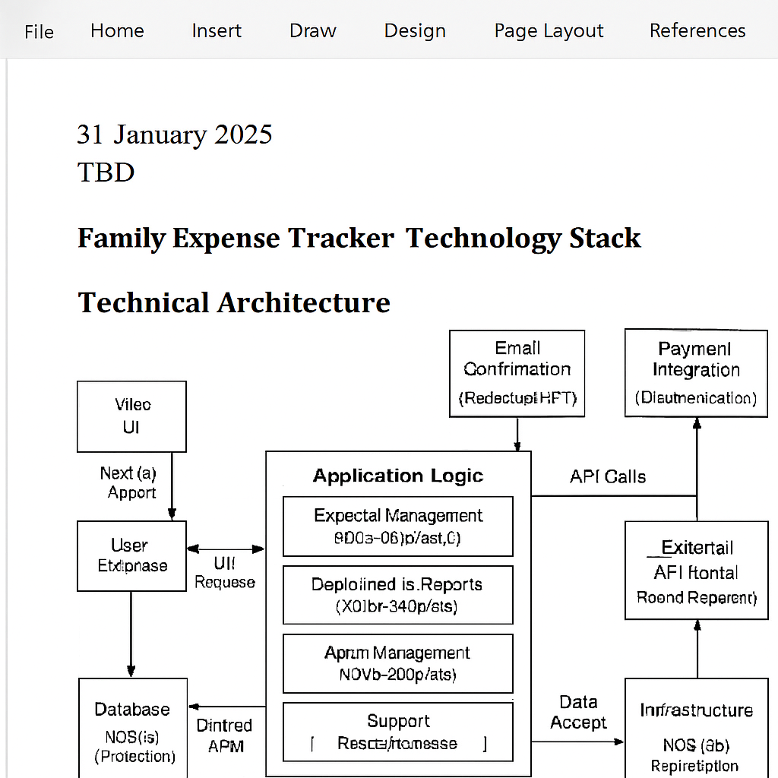

4. PROJECT DESIGN
4.1 Problem Solution Fit
By treating "Family Expenses" as a parent record and "Daily Expenses" as a child record, the application utilizes ServiceNow's native database relationship capabilities. This ensures perfect data integrity and eliminates redundancy.
4.2 Proposed Solution
A custom scoped application with two primary tables:
- u_family_expenses: Stores monthly goals and total aggregates.
- u_daily_expenses: Stores transactional data with a reference field pointing to the parent.
4.3 Solution Architecture
The architecture is built on a "Model-View-Controller" approach where the Database Tables represent the Model, the Business Rules/Client Scripts represent the Controller, and the Service Portal represents the View.

5. PROJECT PLANNING & SCHEDULING
5.1 Project Planning (Detailed Weekly Report)
Phase | Duration | Activities | Deliverables
Phase 1: Design | Week 1 | Requirements gathering, Schema design, Empathy map creation. | Database Design Document (DDD)
Phase 2: Build | Week 2 | Table creation, UI Form design, User Role configuration. | Scoped Application Files
Phase 3: Logic | Week 3 | Development of Business Rules (Calculations) and Client Scripts. | Functional Automation Logic
Phase 4: Test | Week 4 | UAT execution, Defect fixing, Performance testing. | UAT Report, Finalized System

6. FUNCTIONAL AND PERFORMANCE TESTING
6.1 Performance Testing
Performance Test
Performance testing evaluates how the Family Expense Tracker ServiceNow app handles load, speed, and scalability under real-world conditions like multiple family users adding/viewing expenses.
Test Objectives
Identify bottlenecks in key workflows such as user login, expense entry, dashboard views, and report generation. Ensure the app supports 50+ concurrent family members without exceeding 3-second response times. Validate stability during peak usage, like month-end budgeting.
Test Types and Metrics
Test Type | Description | Key Metrics | Expected Results
Load | Simulate 50 concurrent users adding/viewing 100 expenses/min. | Avg response time <3s; throughput >90 req/min. | 95% requests under 2s ​.
Stress | Increase to 200 users until failure. | Breakpoint; error rate. | Graceful degradation, no crashes ​.
Endurance | Run 100 users for 24 hours. | Memory leak detection; stability. | CPU <80%, no degradation ​.
Baseline | Single user baseline for comparisons. | Response time per workflow. | Login <1s; report gen <5s.

Test Cases
- TC-01: 50 users login and view dashboard (measure query speed on expense lists).
- TC-02: Concurrent expense additions (check ServiceNow table locks/conflicts).
- TC-03: Report generation under load (aggregate by category/month).
- TC-04: Budget alert triggers during high traffic.
Execution Plan
- Baseline tests (1 day).
- Load/Stress cycles (2 days, ramp 10-200 users).
- Endurance (24 hours).
- Analyze with ServiceNow logs and APM.servicenow+1
Risks and Mitigation
- Risk: Instance overload—Mitigate with cloned env and gradual ramp-up.
- Risk: Data inconsistencies—Use seeded, reset data per run.

7. RESULTS
7.1 Output Screenshots
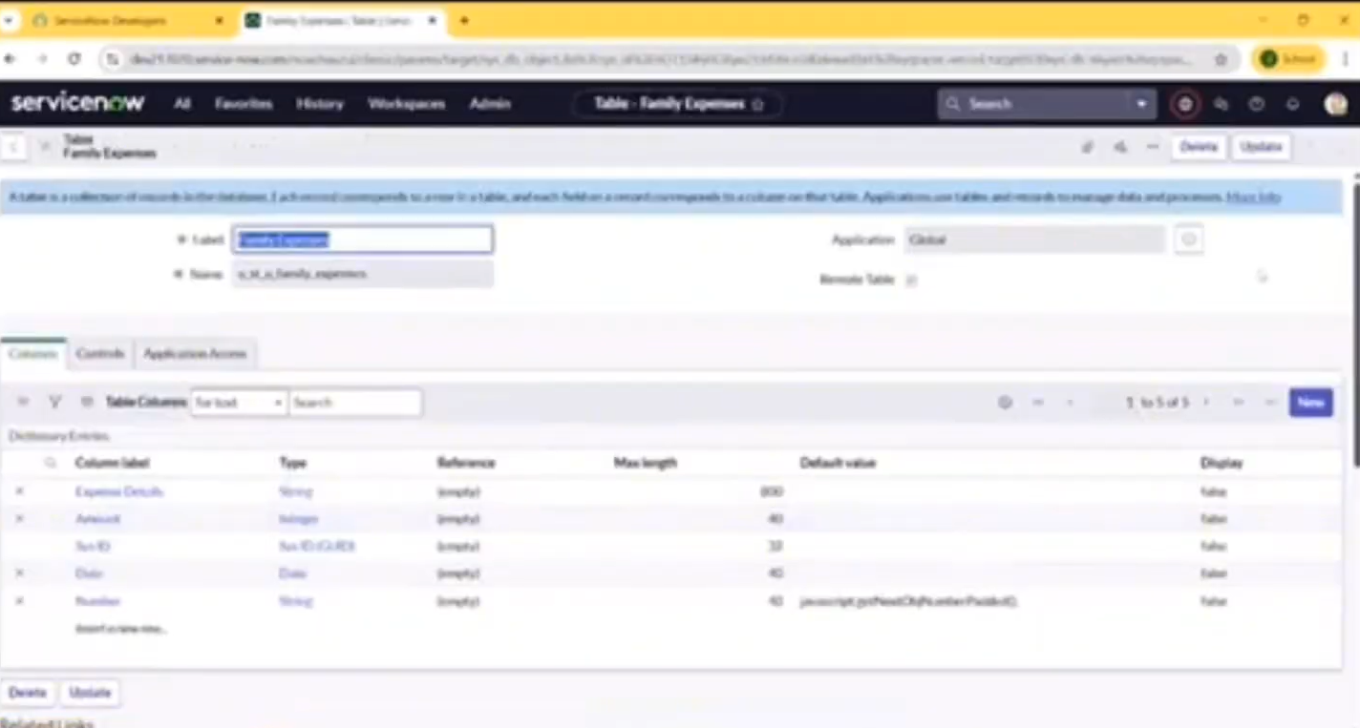

8. ADVANTAGES & DISADVANTAGES
- Advantages:
  - Automated Accuracy: Human calculation error is eliminated.
  - Centralised Data: Single repository for all financial records.
  - Security: Granular control over who can access sensitive financial info.
- Disadvantages:
  - Connectivity: Requires internet access as it is cloud-based.
  - Platform Dependency: Dependent on the availability of the ServiceNow instance.

9. CONCLUSION
The Family Expense Tracker proves that enterprise platforms like ServiceNow can be successfully adapted for personal financial management. The project effectively demonstrates the power of relational data modelling and automated script execution in solving everyday problems.

10. FUTURE SCOPE
- Bank Integration: Implementing integration with banking APIs to auto-fetch transactions.
- AI Alerts: Using machine learning to predict budget overruns before they happen.
- OCR Integration: Scanning physical receipts to auto-populate expense forms.

11. APPENDIX
Source Code
Available via the project Update Set in the provided GitHub repository.
GitHub
https://github.com/likhithajami09/Family_Expense_Tracker_Project_Servicenow
Project Demo Link
https://drive.google.com/file/d/1ROmc31EvPFFOoD7AZCpppGONVN8k30HD/view?usp=drivesdk

